**PERSONAL ASSISTANT ROVER**

EMBEDDED SYSTEMS DEVELOPMENT

ENGINEERING CAPSTONE PROJECT

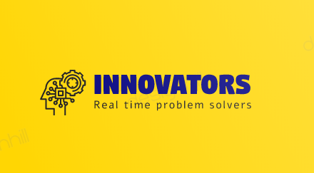

**TEAM MEMBERS**

SANTHOSH NAGENDRAN

SANKEERTH REDDY DARGULA

KUNALSINH RAJENDRASINH GOHIL

GUIDED BY

ALLAN SMITH



850 Fountain Street South, Cambridge, Ontario N3H 0A8, Tel. 519-748-5220.

**ABSTRACT**

We built a Personal Assistant Rover which will grab the objects from the predefined locations and bring it back to the user. To perform this task and to make the rover more interactive with the user and the real world some of the additional features were also included with it. We tried to imitate the human beings by their activities integrated to the rover. This can be operated in two modes; one is the manual mode where the user will take the control of the robot to operate it according to his/her wish. The other one is the autonomous mode where the rover will be operating itself by moving to the user selected predefined locations in its working place.

To make the rover more realistic some of the human activities are integrated such as seeing, hearing, moving, lifting and talking. With all these features incorporated the user will feel more comfortable and handier in using this technology.

In the modern world, the whole world is running behind automation and technology development which are more beneficial to the human beings by bringing down the effort of the humans and giving more work to the machines to take action. If the process becomes simpler and users increase by taking advantages of the technology available, that brings the real technology development and this project is based among the same.

Imagine how about one person sits at their place and does every physical work he likes to do without moving to any of the place. The concept of this project aroused in our minds the same. That was the starting point of the project.

This technology is totally a contribution or dedication for the people in the below mentioning fields such as,

People like physically challenged, bedridden can take advantage of this rover. The main and important strength of the entire nation or the real protagonist are the defence people or people serving as the armed forces. This could be used for the nation such as bomb defusal or even in some risky operations. Also, it would be helpful for the factory people for some daily routine work.

**ACKNOWLEDGEMENT**

We extend our gratitude to our management for having provided us with all facilities to build our project successfully. We express our sincere thanks to our honorable President **JOHN TIBBITS,** for providing us with required amenities.

We express our gratefulness to **MR. MICHAEL JARABEK,** Professorand Program Co-ordinator, Embedded System Development for providing us kind advice during the development of the project.

Our hearty thanks to our guide **MR. ALLAN SMITH,** Professor, Embedded Systems Development, Conestoga College, for his constant support and guidance offered to us during the course of our project by being one among us.

We are committed to place our heartfelt thanks to all teaching and non-teaching staff members and all the noble hearts that gave us immense encouragement towards the completion of our project. Finally, we thank almighty for bestowing the gifts of life on us and also for providing us the necessary help through his lovely creations in this Endeavour of us.

**TABLE OF CONTENTS**

|  |  |  |
| --- | --- | --- |
| **Sr. No.** | **Contents** | **Page No.** |
| 1 | Introduction / Problem Statement | 3 |
| 2 | Proposed Solution | 5 |
| 3 | Technology / Components Used | 8 |
| 4 | Background needed to understand | 13 |
| 5 | Methodology / Steps Taken Throughout the Development |  |
| 6 | Results / Analysis |  |
| 7 | Cost Analysis |  |
| 8 | Recommendations |  |
| 9 | Appendixes |  |

**INTRODUCTION / PROBLEM STATEMENT**

In the current scenario the world is running behind the technology to automate the routine work did by the human and to minimise the human effort, there are so many problems happening in the real world which makes huge work and decreases the efficiency. Likewise, there are so many problems happening and the idea of this project is to point out some of the real-world problem and to develop a system as a solution for the problems which came to our mind but this could be expanded to so many resolutions.

**PROBLEMS FACED**

• Physically challenged people find it difficult to do their own work.

• Bedridden people are not able to their own work, they need personal assistant or some other person to do their work.

• People find it difficult to lift heavy objects and routine works in the factories and ware houses.

• Bomb squad have to go to the field in person to diffuse the bomb which is really risky.

**TECHNOLOGIES USED**

There is no technology which has the capability to solve all the above-mentioned problems all together. There are some of the technologies available in the existing world but they are less interactive, less efficient, high cost and risky operation. Practical happenings of the system will not be more.

There is no technology which will be compatible to use in the household or in the small areas, this one is concentrated for all. This could be used in the factories or in the ware houses even and even in some small places too. Which means this concept is concentrated as one system for all the problem.

**PROPOSED SOULTION**

**RECEIVING PART**

Communication lines

Power Supply

Data lines

5V DC POWER SUPPLY

12-V DC MOTOR

12-V DC POWER SUPPLY

PIXY-2 CAMERA

L293D

ULTRASONIC SENSOR

DC-DC BUCK CONVERTER

SD-CARD MODULE

RF RECEIVER

SPEAKER

AMPLIFIER

PROCESSOR

BLUETOOTH MODULE

3-AXIS SERVO MOTOR

MICRO SD CARD (2GB)

6V DC POWER SUPPLY

**TRANSMITTER PART**

Communication Line

Power Supply

5V DC POWER SUPPLY

Data Line

RF TRANSMITTER

VOICE RECOGNITION MODULE

PROCESSOR

MICROPHONE

As shown above, this is the overall block diagram of the proposed solution. The solution which we have proposed will efficiently solve the problems mentioned above and makes our solution a commercial and multipurpose product. Once buying the product and configuring it accordingly will perform a solution to any of the above-mentioned problems. This can also be used for personal usage.

**CONCEPT OF THE PROJECT**

To keep all the problems in mind and give a generic solution for all together,

We built a rover which can be operated in two modes. The one mode is manual mode where the user will take the overall control of the rover by connecting the rover with his / her personal device through the Bluetooth connection. This personal device which is with the user is the major controlling device and this is also used to switch the modes too.

MOBILE PHONE

ROVER

VOICE RECOGNISER

**VOICE RECOGNISER**

This part will be a separate transmitter part which will be connected to the rover by the help of RF transmitter. The voice recogniser module in the project was run through a third-party software. The recogniser should be connected to the PC along with the circuit, start loading the voice commands into the recogniser. After the voice commands are fed into the recogniser the module is good to connect with the transmitter and it will start sending the corresponding commands whenever the voice command is sensed in the module. When this command is received in the rover through the RF receiver, an SD card module will be fitted along the main circuit of the rover with a micro SD card where all the necessary voice commands or speech back commands should be stored to respond to the respective questions posted in the voice recogniser.

**MOBILE PHONE CONTROL**

As mentioned earlier, the mobile phone control will be the overall control of the project for switching the modes and so. Some of the prefixed commands were mapped accordingly to make some responses to the system.

So, the idea is when the mobile command is passed to the rover, it will start responding to that. So that it allows the users to take the control by moving it front, back, left, right, and stop. It also allows the user to operate the robotic arm attached to the rover. So that they can drive the rover to the desired location and lift any objects if required. When the user selects the autonomous mode of operation, the autonomous operation will be taken care as follows,

A reference picture or track or a object will be placed all around the workplace of the rover. So, this will act as a reference to move the rover around the work place. Some of the pre fixed destinations with separate numbers are coded to it so that it will know where the rover currently is. All this process will be happening based on the camera fit with the rover on the top layer.

These are all the concept which are included in the project.

**TECHNOLOGY / KEY COMPONENTS USED**

* Controller – Atmega2568, Atmega328P (Arduino Mega & Nano).
* Pixy2Camera module.
* Ultrasonic sensor.
* HC-05 Bluetooth module.
* L293D - Two DC motor driver.
* 12V DC motor (2).
* 6V High torque servo motors (4).
* 12V to 6V DC-DC buck converter.
* MicroSD card module.
* 8 Ohms speaker.
* 12V 3.2Ah lead acid battery.
* 5V 10000mAh Battery.
* RF transmitter & receiver.
* Voice recognition module + Microphone.
* LM386 Audio amplifier.

ULTRASONIC SENSOR

* Detecting Range : 3cm to 4.5m.
* Detection Angle : 30 degree
* Power supply : 5v dc supply
* Ultrasonic frequency : 40 kHz
* Trigger pulse width : 10 µs
* Global current consumption : 15 mA

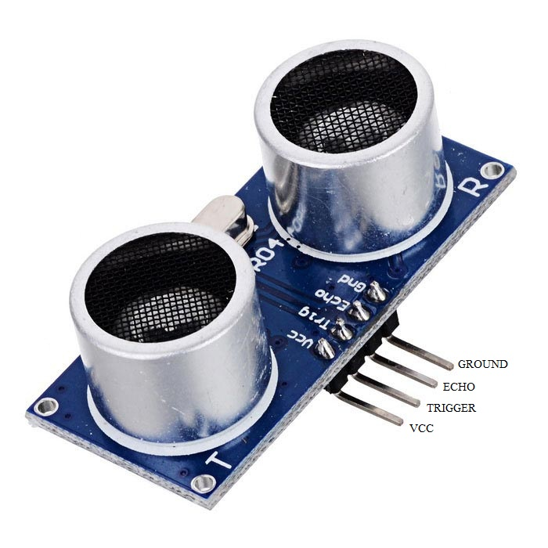

**BLUETOOTH MODULE**

[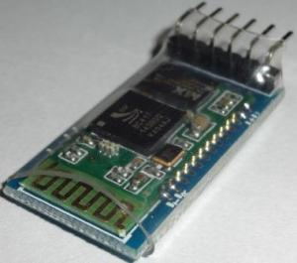](http://i0.wp.com/wiki.jmoon.co/wp-content/uploads/2014/11/JMBLHC05-1.jpg)

* Protocol : Bluetooth Specification v2.0+EDR
* Frequency : 2.4GHz ISM band
* Modulation : GFSK
* Emission power : ≤4dBm, Class 2
* Sensitivity : ≤-84dBm at 0.1% BER
* Speed : Asynchronous: 2.1Mbps(Max) / 160 kbps
* Security : Authentication and encryption
* Profiles : Bluetooth serial port
* Power supply : +3.3VDC 50mA
* Working temperature : -20 ~ +75 Centigrade

**MOTOR DRIVER**

* Voltage range : 4.5v to 36v
* Current : 100 mA to drive motor
* Max resistance : 60 Ώs
* o/p current capability : 600 mA
* Pulsed current : 1.2 mA per drive.
* Package : 16 pin DIP
* Ic weight : 2 gram

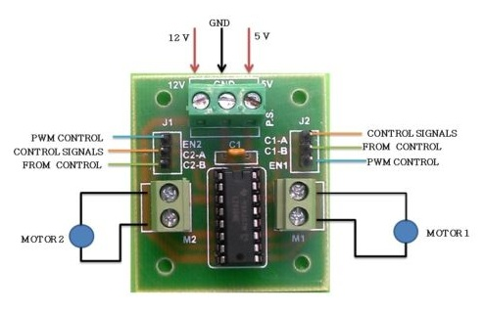

ARDUINO mega

Analog I/o

Reset Switch

Digital I/o

* **GND:** Short for ‘Ground’. There are several GND pins on the Arduino, any of which can be used to ground the circuit.
* **5V & 3.3V:** The 5V pin supplies 5 volts of power and the 3.3V pin supplies 3.3 volts of power. Most of the simple components used with the Arduino run happily off of 5 or 3.3 volts.
* **Analog:** The area of pins under the ‘Analog In’ label (A0 through A5 on the MEGA) is Analog In pins. These pins can read the signal from an analog sensor (like a [temperature sensor](https://www.sparkfun.com/products/10988)) and convert it into a digital value that we can read.
* **Digital:** Across from the analog pins are the digital pins (0 through 13 on the MEGA). These pins can be used for both digital input (like telling if a button is pushed) and digital output (like powering an LED).
* **PWM:** The tilde (~) next to some of the digital pins (3, 5, 6, 9, 10, and 11 on the MEGA) act as normal digital pins, but can also be used for something called Pulse-Width Modulation (PWM).

DC MOTOR

* 12v DC Motor with gear box
* Motor speed = 60rpm
* Base motor speed = 3000rpm
* Shaft diameter = 6mm(with internal hole)
* Weight = 125gm
* Torque = 2kgcm
* No-load current = 60mA(max)
* Load current = 300mA(max)

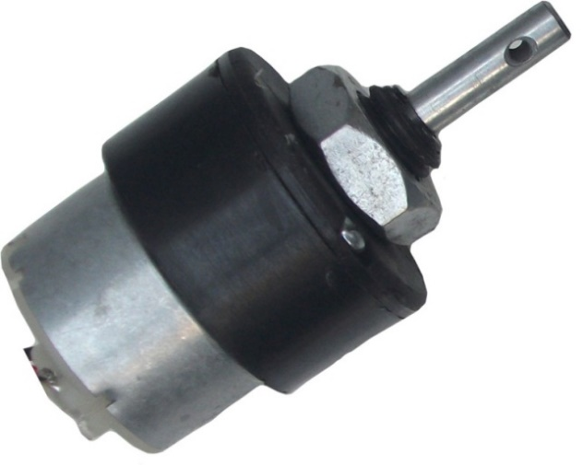

**SD CARD MODULE**

[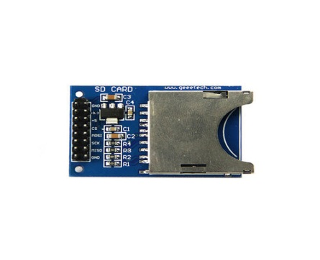](http://www.geeetech.com/wiki/index.php/File:IMG_0283.jpg)

* Break out board for standard SD card.
* Contains a switch to select the flash card slot
* Sits directly on a Arduino
* Also be used with other microcontrollers

[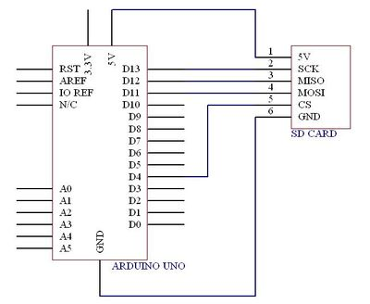](http://www.geeetech.com/wiki/index.php/File:SD_card_wiring.jpg)

*SPI:  
10 (SS) "Slave Select"  
11 (MOSI) "Master Out Slave In"  
12 (MISO) "Master In Slave Out"  
13 (SCK) "System Clock"  
  
To clarify this: to connect this module you must connect:  
(Arduino Pin) - Module Pin  
**10 (SS) to CS  
11 (MOSI) to DI  
12 (MISO) to DO  
13 (SCK) to CLK**  
and **G to GND** and **+ to 5V**  
AND.. Switch the switch to 5V for any Arduino running on 5V.

**SERVO MOTOR**

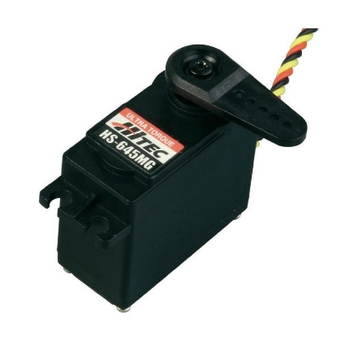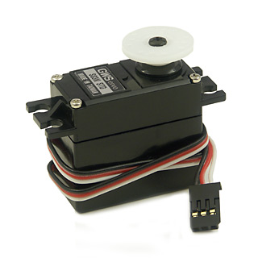

* Weight = 55g
* Dimension = 40.7x19.7x42.9mm
* Stall torque = 11kgf.cm
* Operating speed = 0.14s/60˚
* Operating voltage = 6v
* Running current = 500mA-900mA
* Stall current = 2.5A
* Dead band width = 5µs

**PIXY – 2 CAMERAS**

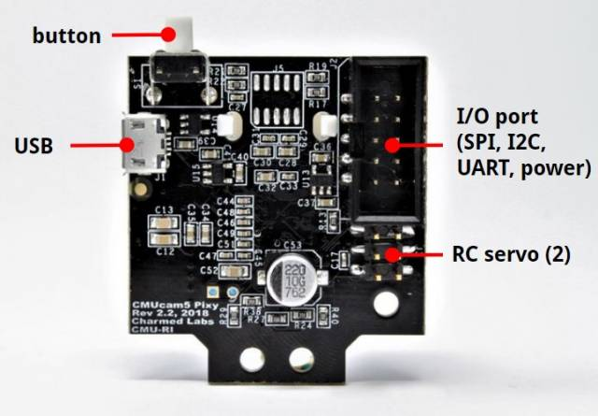

* Processor: NXP LPC4330, 204 MHz, dual core
* Image sensor: Aptina MT9M114, 1296x976 resolution with integrated image flow processor
* Field of view: 60 degrees horizontal, 40 degrees vertical
* Dimensions:1.5” x 1.65” x 0.6”
* Arduino cable, USB cable and mounting brackets included

**BACKGROUND NEEDED TO UNDERSTAND**

There some basic requirements needed for the people to read and understand the theory and concept behind the project developed.

The person reading this document to be an engineer to understand the concepts, he / she should have a minimum knowledge in micro processors and micro controllers as the overall control of the project will be based on the operation of the controllers.

The person should have a good knowledge in electronics and circuits, the basics of circuit theory and basic knowledge in reading and understanding the data sheets given for a device or a component. This document will also have some inputs in connecting the circuits to make it work.

Should also have good knowledge in hardware’s and their usage in different places.

Little experience in testing and debugging will also help to understand lot. When the person reading the document tries to test as the flow or on the go he will be feeling easy to use it and will also have a good understanding along the pitch.

These are all the basic things needed for a person to read and understand the document.

**METHODOLOGY / STEPS TAKEN THROUGHT DEVELOPMENT**

* We spent quite a time to finalize our project’s concept.
* We were researching about the component’s selection.
* The shipping period of the components were used wisely by writing some codes to test each of the components while they arrive in.
* Testing of all the components individually was successful.
* A small checklist has been developed for interfacing corresponding modules.
* We faced many hurdles throughout the process.
* We came across alternative solutions to resolve the problems with proper research & guidance.

**RESULTS / ANALYSIS**

* A clear idea of the concept that fits to the real-world problems have been developed.
* Collection of components have been done as planned.
* Separate software patches have been created for testing every single component.
* We interfaced the components accordingly.
* We went through lot of troubles throughout the process and fixed the same after gathering necessary information.
* We achieved decent results and created a solution for operating the rover in manual mode and autonomous mode.
* Our main goal was to make a rover to solve the real-world problems economically.
* We came up with two modes to make things happen, both the modes are working fine independently.
* We faced a power consumption issue on switching the modes.
* When we combined both the modes with switching control, it did not go well as expected.

**COST ANALYSIS**

|  |  |  |
| --- | --- | --- |
| S.NO | ITEM | PRICE |
| 1. | 12 V 3.3APH LEAD ACID BATTERY | $28 |
| 2. | ROBOT CHASSIS | $140 |
| 3. | BLUETOOTH MODULE | $11 |
| 5. | BATTERY CHARGER | $17 |
| 6. | ROBOTIC ARM | $35 |
| 7. | 4 SERVO MOTORS | $46 |
| 8. | VOICE RECOGNITION MODULE | $28 |
| 9. | AUDIO AMPLIFIER | $12 |
| 10. | SD CARD | $15 |
| 11. | SD CARD MODULE | $7.50 |
| 12. | PIXY CAMERA | $95 |
| 13. | DC-DC BUCK CONVERTER | $13 |
| 14. | JUMPER WIRES | $10 |
| 15. | 2 USB TO TTL | $22 |
| **16.** | **TOTAL** | **$479.50** |

**RECOMMENDATIONS**

The problem we faced was the power issue. When we connect pixy2camera with the Arduino mega then the pixy2camera was not working. We figured we are facing this issue because of power.

The second problem was we were facing is switching between automatic mode and manual mode. When we use the manual mode separately then it works perfectly fine but when we use both the modes together then we were facing some connectivity issues.

So the person reading this document and trying to develop the same with some add on features should concentrate more on the power consumptions for the overall systems.

**CHITTI**

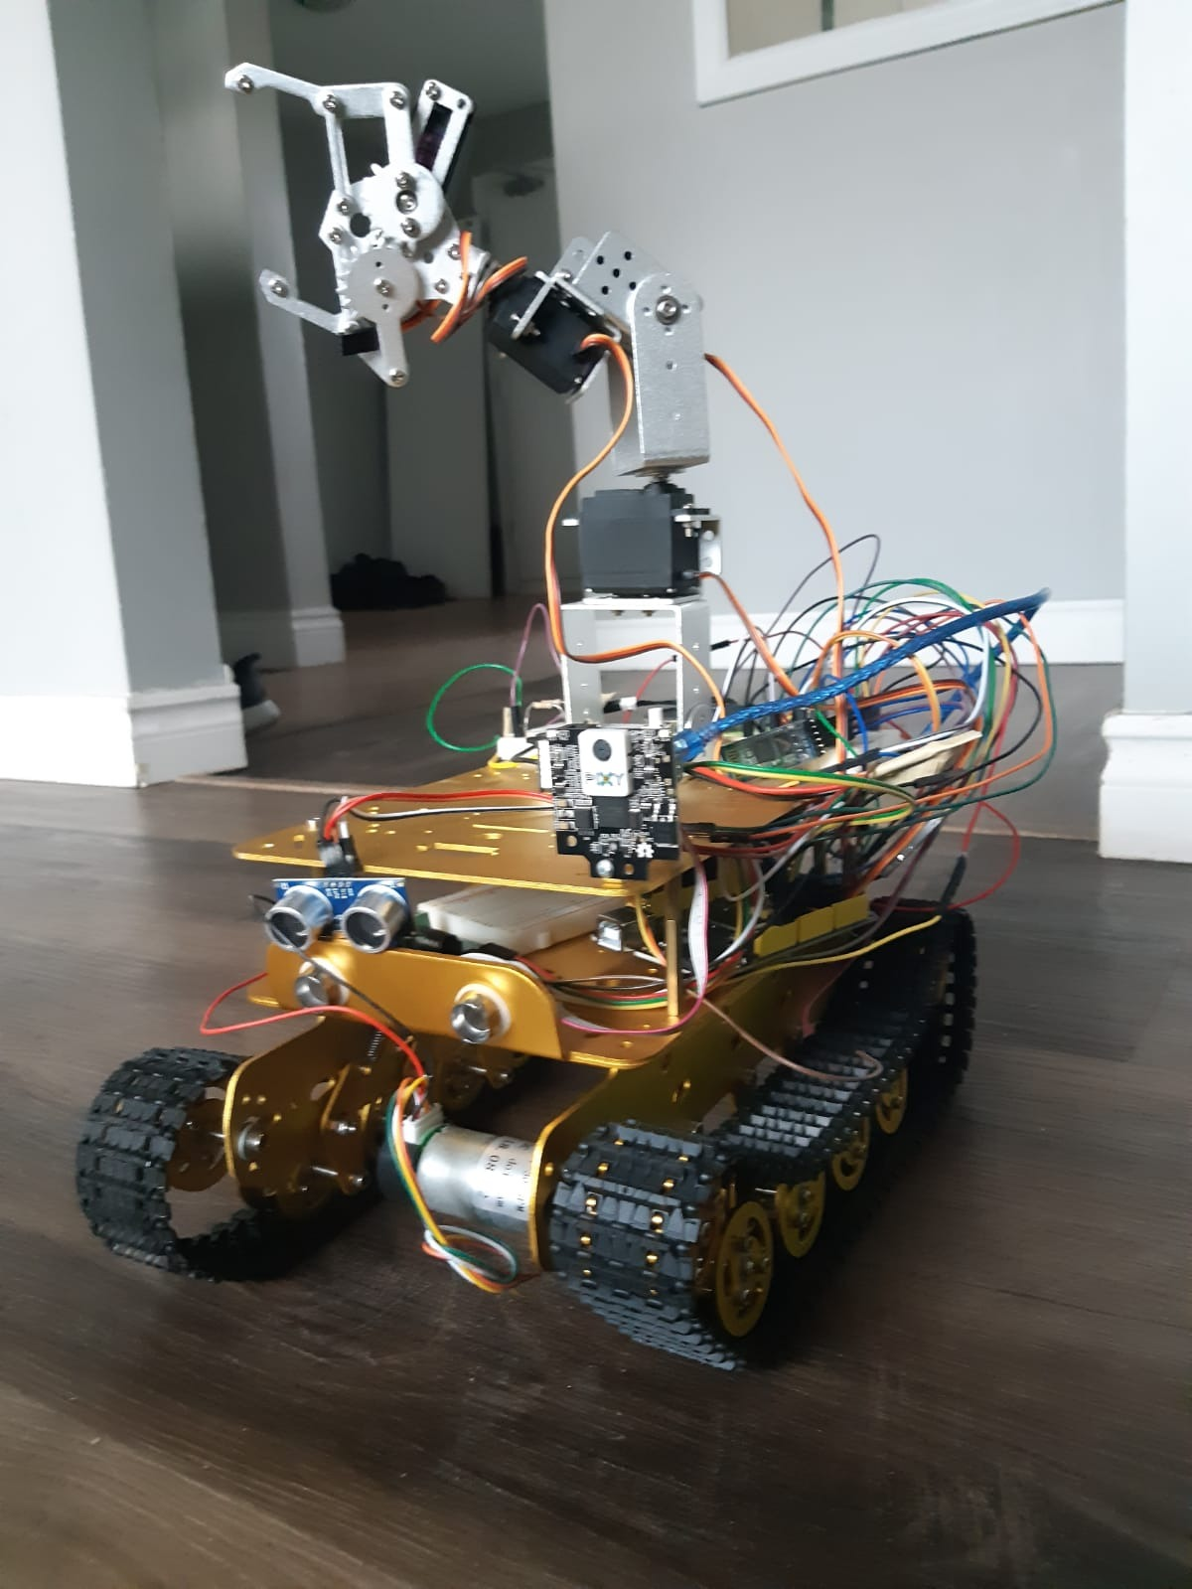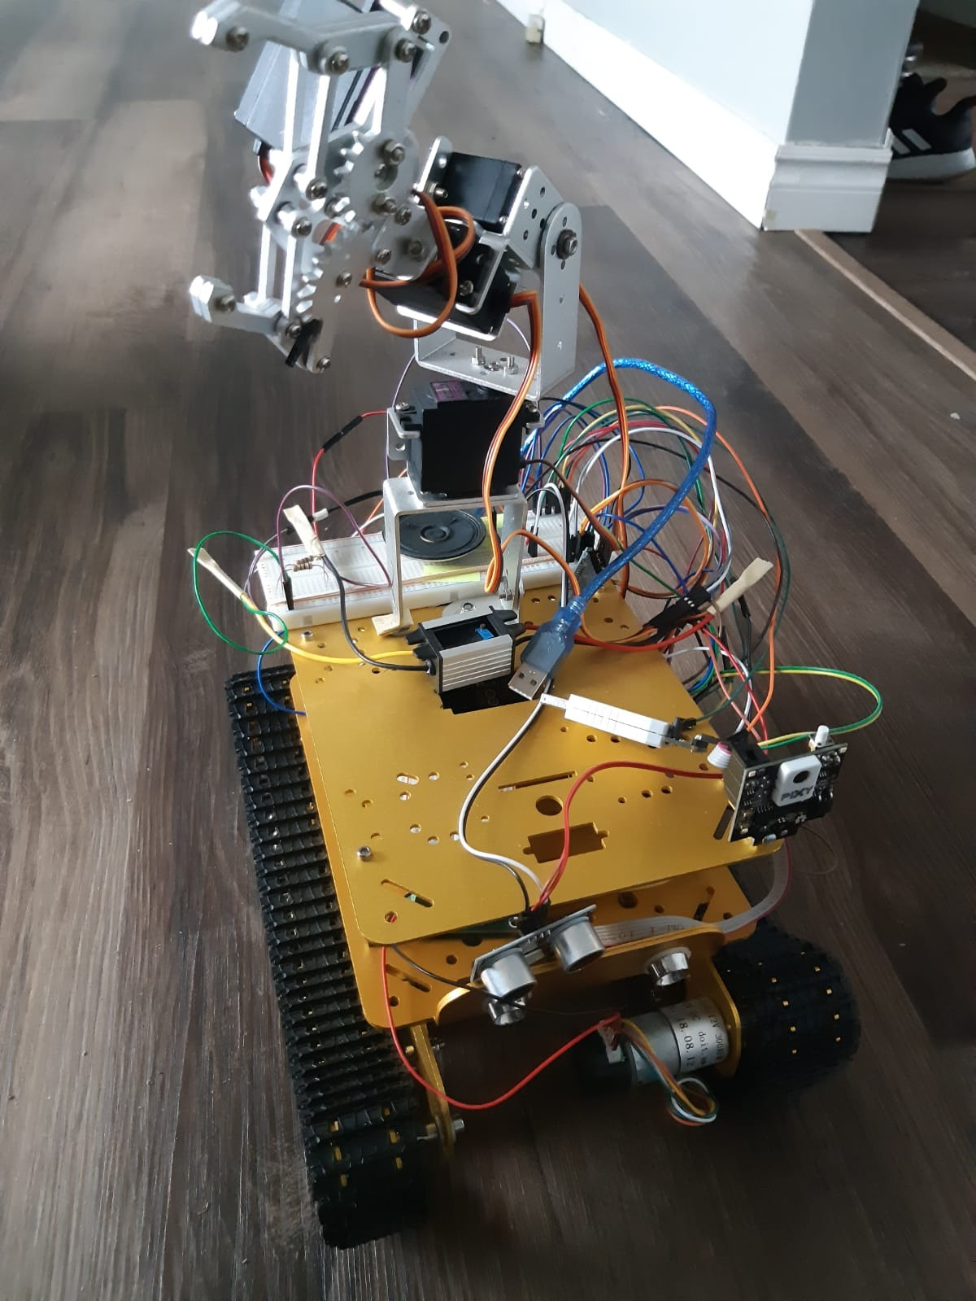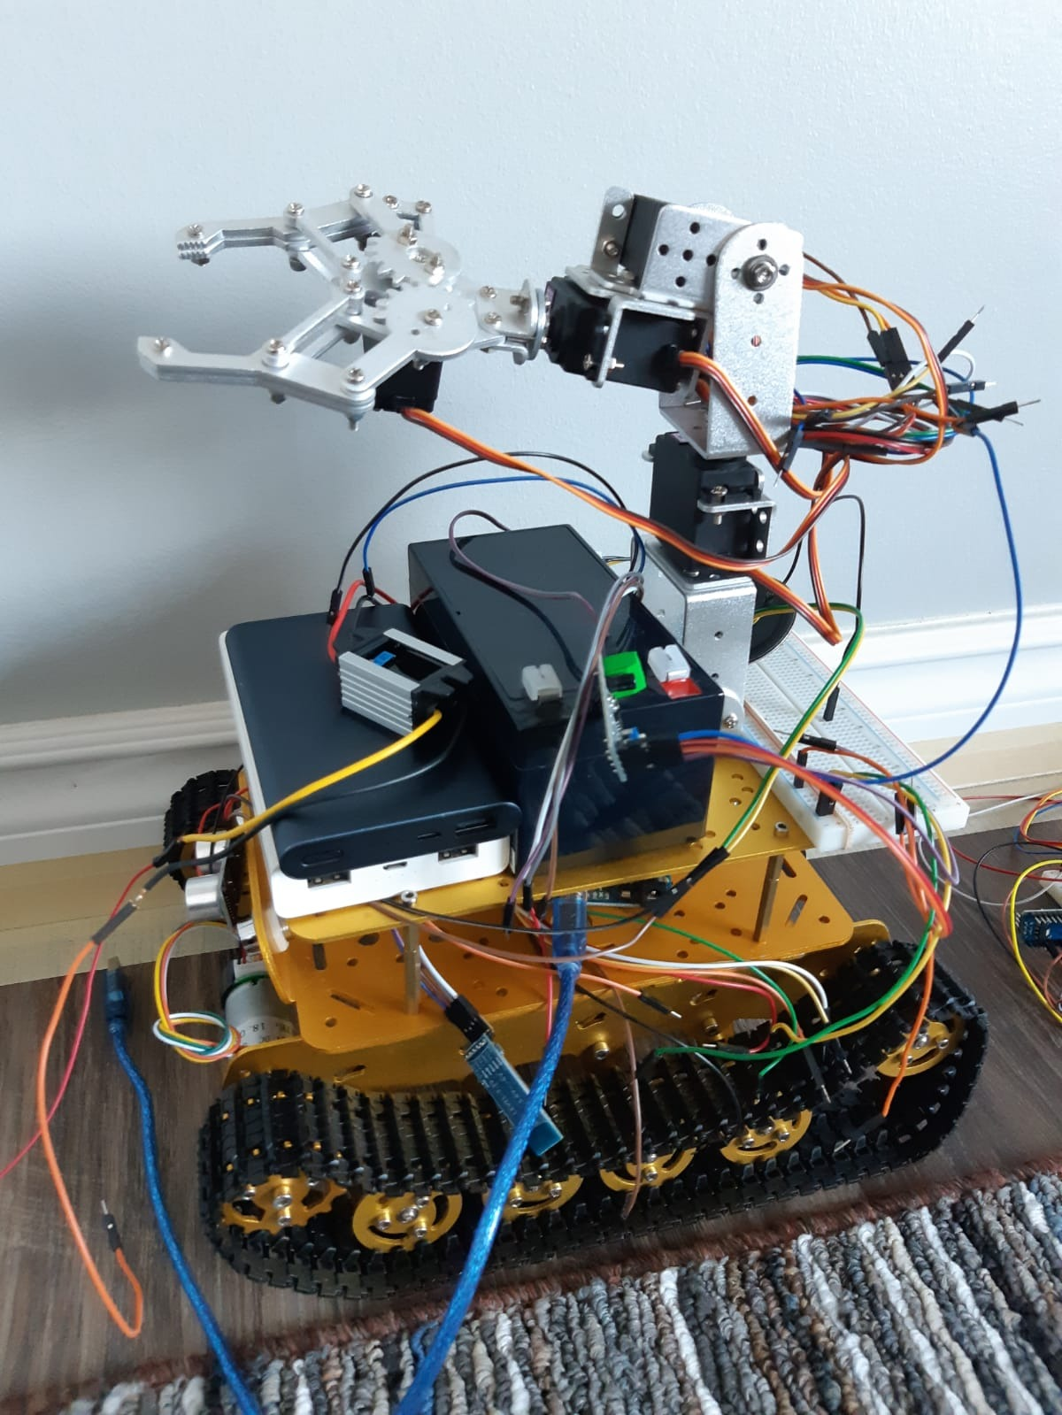

**FUTURE SCOPE**

* Since there were power issues when interfacing the camera, this part should give more time in future.
* The circuit can be designed in PCB.

**REFERENCES**

<https://dronebotworkshop.com/pixy2-camera/>

<https://resources.robokits.co.in/line-follower-robot-using-pixy2-arduino/>

<https://docs.pixycam.com/wiki/doku.php?id=wiki:v2:arduino_api>

<https://robokits.download/downloads/pixy_linefollower_final.ino>

<https://docs.pixycam.com/wiki/doku.php?id=wiki:v2:line_api>

<https://docs.pixycam.com/wiki/doku.php?id=wiki:v2:line_quickstart>

<https://www.youtube.com/watch?v=Ur1tzMDP97g&t=263s>

<https://www.ardumotive.com/how-to-use-a-voice-recognition-module.html>

<https://www.instructables.com/id/Micro-SD-Card-Tutorial/>

<https://www.instructables.com/id/Audio-Player-Using-Arduino-With-Micro-SD-Card/>

<https://www.instructables.com/id/Arduino-Bluetooth-Basic-Tutorial/>

<https://www.instructables.com/id/RF-315433-MHz-Transmitter-receiver-Module-and-Ardu/>

<https://www.tutorialspoint.com/arduino/arduino_ultrasonic_sensor.htm>

<https://core-electronics.com.au/tutorials/dc-motors-with-arduino.html>

<https://www.instructables.com/id/Arduino-Servo-Motors/>